Appendix

Designation of an area for Selective Licensing

**Oxford City Council - Designation of an Area for Selective Licensing No.2 20XX.**

Oxford City Council in exercise of their powers under section 80 of the Housing Act 2004 (“the Act”) hereby designates for selective licensing the area described in paragraph 4.

CITATION, COMMENCEMENT AND DURATION

1. This designation may be cited as Oxford City Council Designation for an Area for Selective Licensing No 2, 20XX

2. This designation is made on XXXX20XX and requires confirmation by the Secretary of State for Housing Communities and Local Government

3. This designation shall come into force on a date specified for this purpose by the Secretary of State for Housing Communities and Local Government and shall cease to have effect five years after such date.

DESIGNATION AND AREA

4. The Council hereby designates under section 80 of the Act as subject to selective licensing the area within the district of Oxford City Council shaded grey, excluding Holywell Ward, on the map at Annex A

Annex A – Paragraph 4: Map of Designated Area

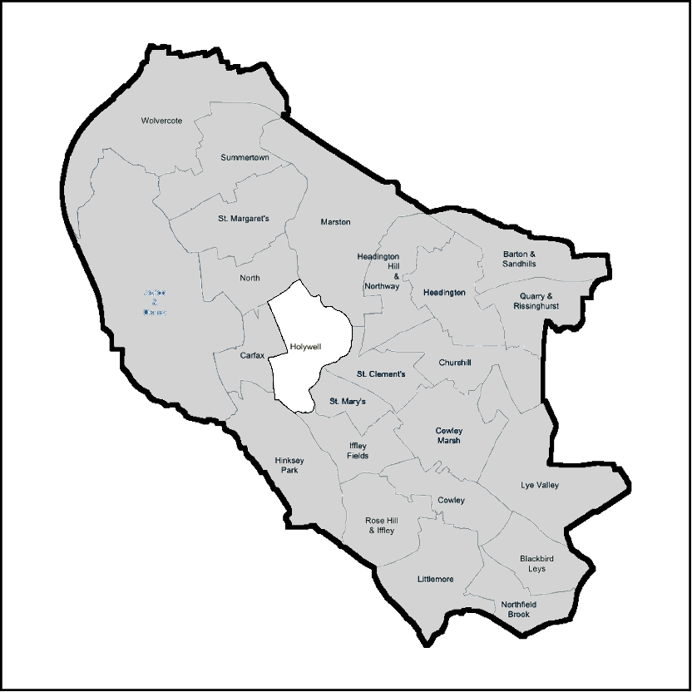

*(Please Note: The legislation cited below is up to date as at 19th January 2021 and may be subsequently amended).*

APPLICATION OF THE DESIGNATION

5. This designation applies to any house[1] which is let or occupied under a tenancy or licence within the area described in paragraph 4 unless –

(a) the house is a house in multiple occupation and is required to be licensed under Part 2 of the Act[2];

(b) the tenancy or licence of the house has been granted by a registered social landlord[3];

(c) the house is subject to an Interim or Final Management Order under Part 4 of the Act;

(d) the house is subject to a temporary exemption under section 86 of the Act; or

(e) the house is occupied under a tenancy or licence which is exempt under the Act[4] or the occupation is of a building or part of a building so exempt as defined in annex b;

EFFECT OF THE DESIGNATION

6.Subject to sub paragraphs 5(a) to (e) every house in the area specified in paragraph 4 that is occupied under a tenancy or licence shall be required to be licensed under section 85 of the Act.[5]

7. Oxford City Council will comply with the notification requirements contained in section 83 of the Act and shall maintain a register of all houses registered under this designation as required under section 232 of the Act.[6]

Head of Regulatory Services and Community Safety

Date:XXXX 20XX

The Secretary of State for Housing, Communities and Local Government under the power conferred on him by section 82 (2) of the Act hereby confirms the scheme described above

Signed

An officer authorised by the Secretary of State

Date

Annex B – Paragraph 5(d): Exempted Tenancies or licences[7]

**Prohibition of occupation by law**

1. A tenancy or licence of a house[8] or a dwelling[9] within a house where the house or the dwelling is subject to a prohibition order made under section 20 of the Act the operation of which has not been suspended under section 23.

**Certain tenancies which cannot be assured tenancies**

2. A tenancy which cannot be an assured tenancy by virtue of section 1 (2) of the Housing Act 1988 and falling within any paragraph in Part I of Schedule 1 of that Act and which is:

(a) a business tenancy under Part II of the Landlord and Tenant Act 1954;

(b) a tenancy under which the dwelling-house consists of or comprises premises, which, by virtue of a premises licence under the Licensing Act 2003, may be used for the supply of alcohol (within the meaning of Section 14 of that Act) for consumption on the premises[10];

(c) a tenancy under which agricultural land, exceeding two acres, is let together with the house[11];

(d) a tenancy under which the house is comprised in an agricultural holding or the holding is comprised under a farm business tenancy if it is occupied (whether as tenant or as a servant or agent of the tenant), in the case of an agricultural holding, by the person responsible for the control of the farming of the holding, and in the case of a farm business tenancy, by the person responsible for the control of the management of the holding[12].

**Tenancies and licences granted etc by public bodies**

3. A tenancy or licence of a house or dwelling within a house that is managed or controlled[13] by:

(a) a local housing authority;

(b) a police authority established under section 3 of the Police Act 1996 or the Metropolitan Police Authority established under section 5B of that Act;

(c) a fire and rescue authority under the Fire and Rescue Services Act 2004;

(d) a health service body within the meaning of section 4 of the National Health Service and Community Care Act 1990.

**Tenancies, licences etc regulated by other enactments**

4. A tenancy, licence or occupation of a house which is regulated under the following enactments:

(a) sections 87 to 87D of the Children Act 1989;

(b) section 43 (4) of the Prison Act 1952;

(c) section 34 of the Nationality, Immigration and Asylum Act 2002;

(d) The Secure Training Centre Rules 1998[14];

(e) The Prison Rules 1999[15];

(f) The Young Offender Institution Rules 2000[16];

(g) The Detention Centre Rules 2001[17];

(h) The Criminal Justice and Court Service Act 2000 (Approved Premises) Regulations 2001[18];

(i) The Care Homes Regulations 2001[19];

(j) The Children’s Homes (England) Regulations 2015[20];

(k) The Residential Family Centres Regulations 2002[21].

**Certain student lettings etc**

5. A tenancy or licence of a house or a dwelling within a house –

(i) which is managed or controlled by a specified educational establishment or is of a specified description of such establishments and

(ii) the occupiers of the house or dwelling are undertaking a full time course of further or higher education at the specified establishment[22] and

(iii) the house or dwelling is being managed in conformity with an Approved Code of Practice for the management of excepted accommodation under section 233 of the Act[23]

**Long leaseholders**

6. A tenancy of a house or a dwelling within a house provided that –

(i) the full term of the tenancy is for more than 21 years and

(ii) the tenancy does not contain a provision enabling the landlord (or his successor his in title) to determine it other than by forfeiture, earlier than at the end of the term and

(iii) the house or dwelling is occupied by a person to whom the tenancy was granted or his successor in title or by any members of either of those person’s family.

**Certain family arrangements**

7. A tenancy or licence of a house or a dwelling within a house where –

(i) the person who has granted the tenancy or licence to occupy is a member of the family of the person who has been granted the tenancy or licence and

(ii) the person who has granted the tenancy or licence to occupy is the freeholder or long leaseholder of the house or dwelling and

(iii) the person occupies the house or dwelling as his only or main residence (and if there are two or more persons at least one of them so occupies).

**Holiday lets**

8. A tenancy or licence of a house or a dwelling within a house that has been granted to the person for the purpose of a holiday.

**Certain lettings etc by Resident Landlord etc**

9. A tenancy or licence of a house or a dwelling within a house under the terms of which the person granted the tenancy or licence shares the use of any amenity with the person granting that tenancy or licence or members of that person’s family. An “amenity” includes a toilet, personal washing facilities, a kitchen or a living room but excludes any area used for storage, a staircase, corridor or other means of access.

**Interpretation**

In Annex B -

(a) a “person” includes” persons”, where the context is appropriate;

(b) a “tenancy” or “licence” includes “a joint tenancy” or “joint licence”, where the context is appropriate;

(c) “long leaseholder” in paragraph 7 (ii) has the meaning conferred in paragraphs 6 (i) and (ii) and in those paragraphs the reference to “tenancy” means a “long lease”;

(d) a person is a member of the family of another person if –

(i) he lives with that person as a couple;

(ii) one of them is the relative of the other; or

(iii) one of them is, or is a relative of, one member of a couple and the other is a relative the other member of the couple

and

(iv) For the purpose of this paragraph –

(1) “couple” means two persons who are married to each other or live together as husband and wife or in an equivalent arrangement in the case of persons of the same sex;

(2) “relative” means a parent, grandparent, child, grandchild, brother, sister, uncle, aunt, nephew, niece or cousin;

(3) a relationship of the half-blood is to be treated as a relationship of the whole blood and

(4) a stepchild of a person is to be treated as his child

1. For the definition of “house“ see sections 79 and 99 of the Act
2. Section 55 of the Act defines which Houses in Multiple Occupation are required to be licensed under the Act. See also The Licensing of Houses in Multiple Occupation (Prescribed Descriptions) (England) Order 2006 (SI 2006/371)
3. Section 79 (3) of the Act. For the definition of a Registered Social Landlord see Part 1 of the Housing Act 1996
4. Section 79 (4) of the Act and the Selective Licensing of Houses (Specified Exemptions) (England) Order SI 2006/370
5. Section 86 of the Act provides for certain temporary exemption. As to suitability see section 89. Note, if the house is not suitable to be licensed the Council must make an Interim Management Order-see section 102.
6. 6 Section 232 of the Act, regulation 11 of Licensing and Management of Houses in Multiple Occupation and Other Houses (Miscellaneous Provisions) (England) Regulations SI 2006/373
7. See The Selective Licensing of Houses (Specified Exemptions) (England) Order 2006 SI 2006/370
8. Sections 79 (2) and 99 of the Act
9. For the definition of a dwelling – see section 99 of the Act
10. See paragraph 5 of Schedule 1 of the 1988 Act as amended by section 198 (1) and paragraph 108 of schedule 6 of the Licensing Act 2003
11. For the meaning of “agricultural land” section 26 (3) (a) of the General Rate Act 1967
12. See paragraph 7 of Schedule 1 of 1988 Act as amended by section 40 and paragraph 34 of the Schedule to the Agricultural Tenancies Act 1995
13. For the definition of “person managing” and “person having control” see section 263 of the Act
14. SI 1998/472 as amended
15. SI 1999/728 as amended
16. SI 2000/3371 as amended
17. SI 2001/238. Section 66 (4) of the Nationality, Immigration and Asylum Act 2002 provides that the reference to a detention centre is to be construed as a reference to a removal centre as defined in Part VIII of the Immigration and Asylum Act 1999
18. SI 2001/850
19. SI 2001/3965 as amended
20. SI 2015/541
21. SI 2002/3213 as amended
22. See the schedule to The Houses in Multiple Occupation (Specified Educational Establishments) (England) Regulations 2016 for the list of specified bodies
23. The relevant codes of practice are approved under The Housing (Codes of Management Practice) (Student Accommodation) (England) Order 2010/2615 and specified in paragraphs 2 - 4 of that Order